**20.Write a program to demonstrate implementation of JMeter controllers using Selenium.**

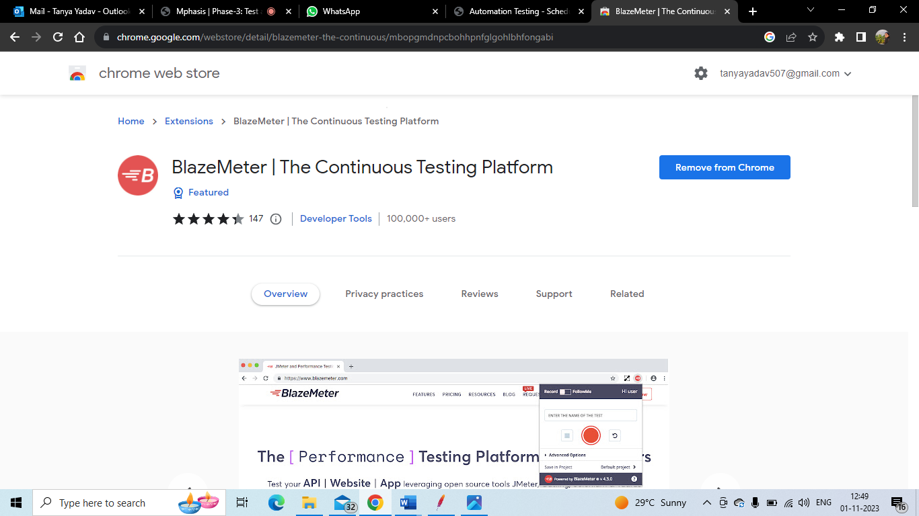

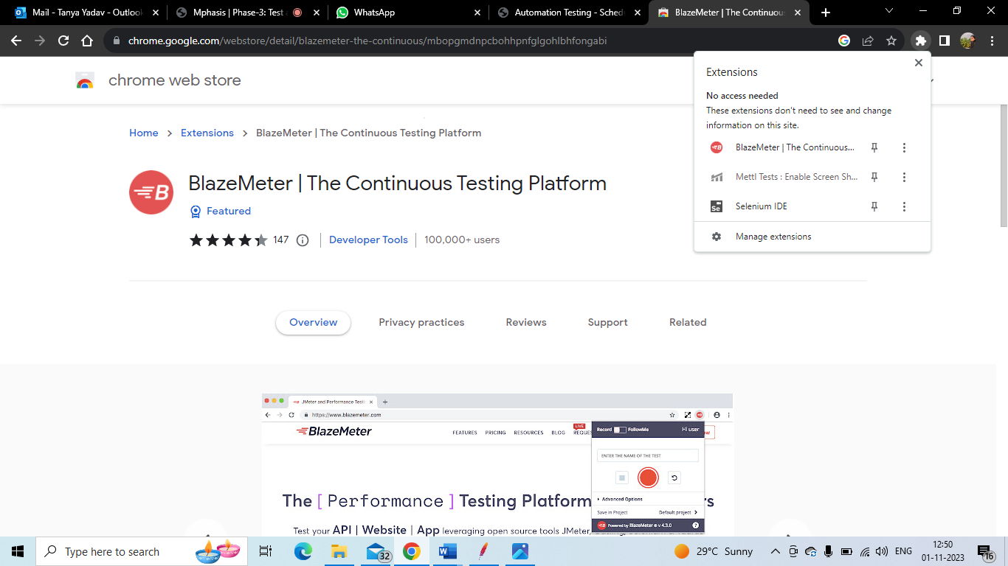

Click on Signup

Always loginto blazemeter before recording script

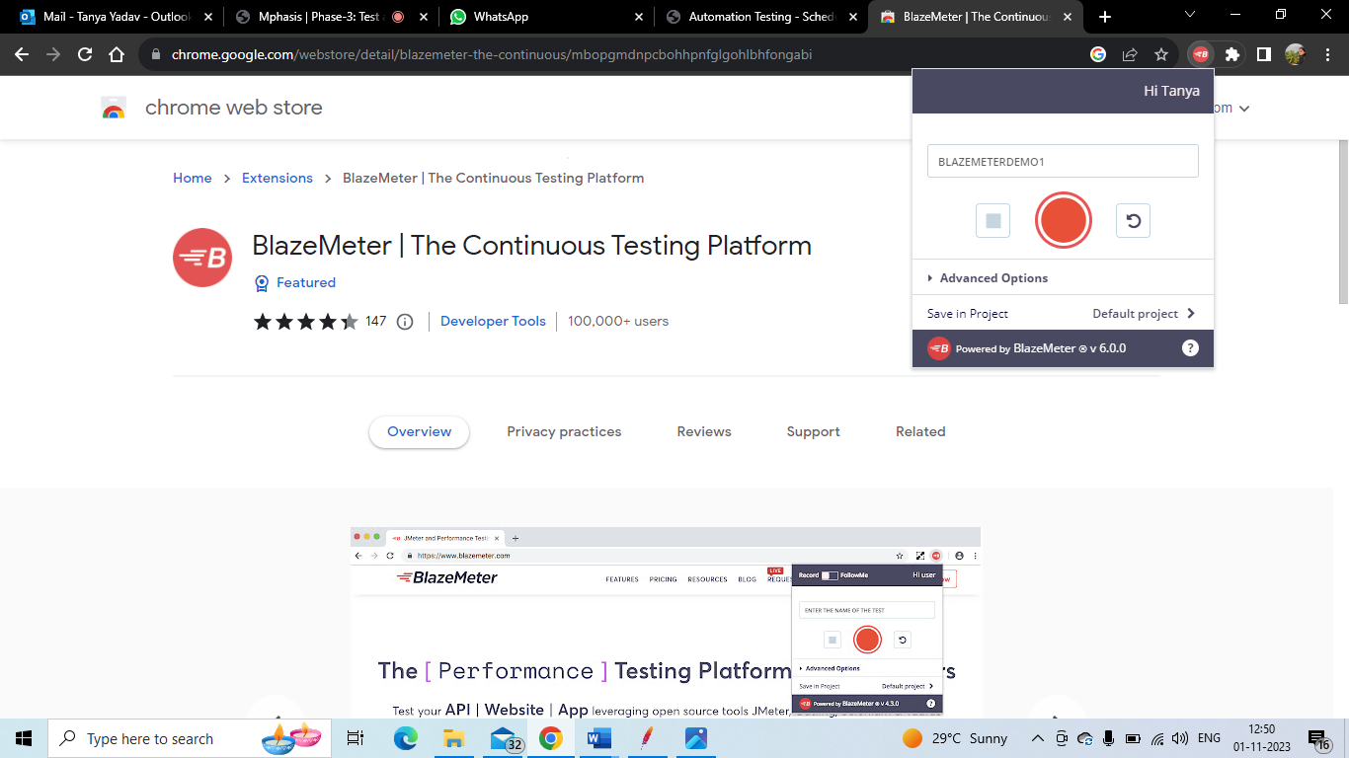

Click on red button to start recording

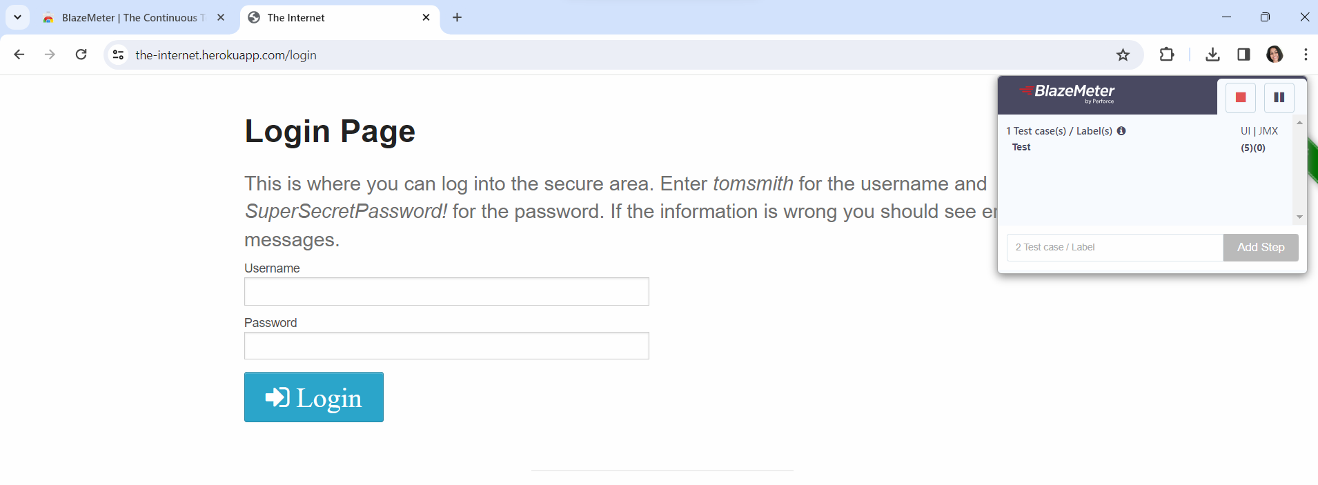

Click on red button to stop recording

To get the recording 🡪 again open the blazemeter extensison 🡪 save button🡪 click 🡪 save as JMX file

The file will be downloaded in your downloads folder

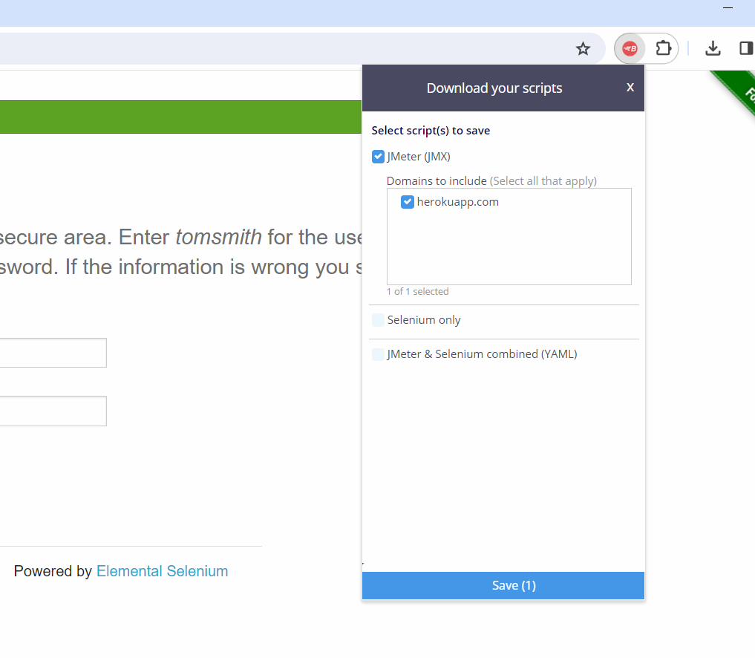

Script will be in downloads folder

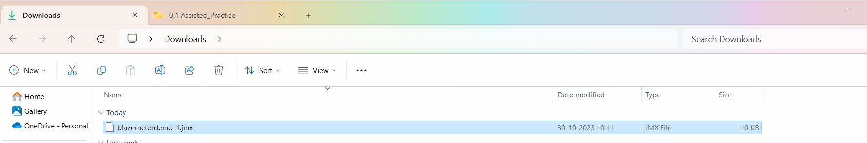

Now open the script in Jmeter

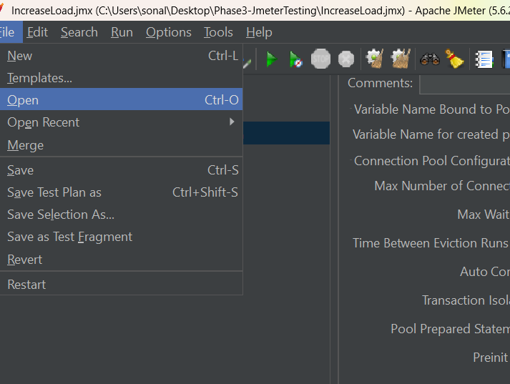

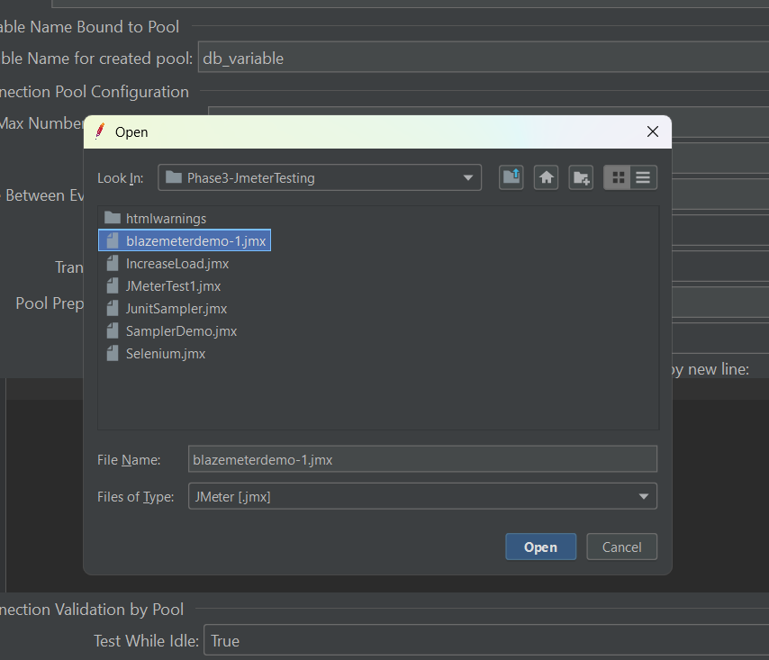

You can move the scripts in Simple controllers and apply naming policy

